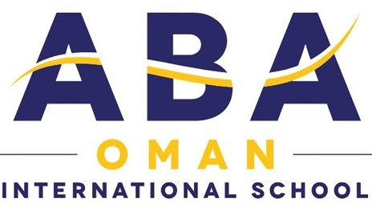

T: (+968) 2495500, PO Box 372, PC 115, Madinat Qaboos, Muscat - Sultanate of Oman

Board Elections Video Recording Consent Form

Please return the completed slip with the nomination form.

I acknowledge that my speech on the 18th of May 2021 will be recorded and placed on the parent portal for the ABA community for viewing during the election period.

Links to the recordings will also be placed on ElectionBuddy, the online voting platform ABA will be using this year, for voters to refer to as they vote.

Full Name: __________________________
Signature: __________________________
Date: ____________________

